CPS470: Computer Networks and Security

Written Homework 6
Total Points: 100
Grant Harvey

Note: In all written assignments, please show as much of your work as you can. Even if you get a wrong answer, you can get partial credit if you show your work. If you make a mistake, it will also help the grader show you where you made a mistake. You can either type your answers in the solution area and submit the file directly on Isidore or hand-write your answers and get a scanned version of it to submit on Isidore. If you find the default space is not sufficient for you to type/handwrite your answers, please feel free to enlarge the space as needed. Please make sure your handwriting is clear and understandable. If the grader or I cannot understand your handwriting, you get zero for your solutions.

Problem 1: Error detection and Correction. Show (give an example other than the one in the slides) that two-dimensional parity checks can correct and detect a single bit error. Show (give an example of) a double-bit error that can be detected but not corrected.
Solution:
Starting bits
1 0 1 1 | 1
0 1 0 1 | 0
1 1 0 0 | 0
0 0 1 1 | 0
-----------
0 0 0 1

Example of two-dimensional parity checks detecting and correcting a single bit error.
1 0 1 1 | 1
0 1 1 1 | 0 ← error
1 1 0 0 | 0
0 0 1 1 | 0
-----------
0 0 0 1
Flip that highlighted 1 back to 0 and it will be corrected

Example of a double-bit error that can be detected but not corrected.
0 0 1 1 | 1 ← error
0 0 0 1 | 0 ← error
1 1 0 0 | 0
0 0 1 1 | 0
-----------
0 0 0 1
It can detect there is an error here, but it wont be able to fix it since it is over multiple rows and columns.

Problem 2: Cyclic Redundancy Check. Consider the 5-bit generator, G=10011, and suppose that D has the value 1010101010. What is the value of R?
Solution:
1011011100
10011$\sqrt{10101010100000}$
10011
11001
10011
10100
10011
11110
10011
11010
10011
10010
10011
0100 = R

Problem 3: ARP and Learning Switches. Consider the network shown below.

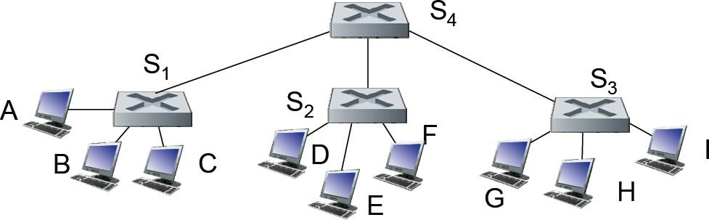
Suppose that source node A wants to send an IP datagram, encapsulated in an Ethernet frame to node H. Before doing so, A uses ARP to find H’s MAC address. A then sends an Ethernet frame to H and H then sends a reply back to A. Suppose that initially the switch tables are empty at all switches, and that all ARP tables are empty.
- Give the switch tables for S₁, S₂, S₃ and S₄ after the ARP request packet is received at H.
- How many of hosts A through F receive the ARP request?
- Give the switch tables for S₁, S₂, S₃ and S₄ after the ARP reply packet has been sent by H and has been received at A.
- Give the switch tables for S₁, S₂, S₃ and S₄ after the IP datagram has been sent by A and has been received at H.
- How many of hosts A through F receive the frame containing the A-to-H datagram?

Solution:
a)
Switch S1
MAC Address | Interface | TTL
A | A | -

Switch S2
MAC Address | Interface | TTL
A | S4 | -

Switch S3
MAC Address | Interface | TTL
A | S4 | -

Switch S4
MAC Address | Interface | TTL
A | S1 | -

b)
Everyone but the sender, so B, C, D, E, F or 5 host

c)

Switch S1
MAC Address | Interface |
A | A |
H | S4 |

Switch S2
MAC Address | Interface |
A | S4 |

Switch S3
MAC Address | Interface |
A | S4 |
H | H |

Switch S4
MAC Address | Interface |
A | S1 |
H | S3 |
d)
Same table as c

e)
This time it's not a broadcast since we did that earlier to get the path, it just does a direct path A - S1 - S4 - S3 - H
So it should be 0 host

Problem 4. Link Layer (and network layer) addressing and forwarding -1. Consider the figure below. The IP and MAC addresses are shown for nodes A, B, C and D, as well as for the router's interfaces.
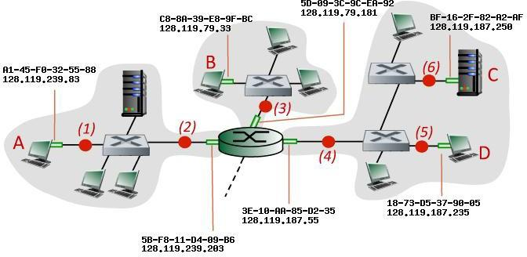

Consider an IP datagram being sent from node D to node A. Give the source and destination Ethernet addresses, as well as the source and destination addresses of the IP datagram encapsulated within the Ethernet frame at points (5), (4), (2), and (1) in the figure above.
Solution:

(5)
Source Ethernet = 18-73-05-37-98-85
Destination Ethernet = 3E-10-AA-85-02-35
Source IP = 128.119.187.235
Destination IP = 128.119.239.83

(4)
Source Ethernet = 18-73-05-37-98-85
Destination Ethernet = 3E-10-AA-85-02-35
Source IP = 128.119.187.235
Destination IP = 128.119.239.83

(2)
Source Ethernet = 5B-F8-11-04-89-B6
Destination Ethernet = A1-45-F8-32-55-88
Source IP = 128.119.187.235
Destination IP = 128.119.239.83

(1)
Source Ethernet = 5B-F8-11-04-89-B6
Destination Ethernet = A1-45-F8-32-55-88
Source IP = 128.119.187.235
Destination IP = 128.119.239.83

Basically the IP source and destination will never change while the ethernet does

Problem 5. Link Layer (and network layer) addressing and forwarding - 2. Consider again the figure above. The IP and MAC addresses are shown for nodes A, B, C and D, as well as for the router's interfaces. Now suppose that the router in the above diagram is replaced by a switch. Consider again an IP datagram being sent from node D to node A. Give again the source and destination Ethernet addresses, as well as the source and destination addresses of the IP datagram encapsulated within the Ethernet frame at points (5), (4),(2), and
- in the figure above for the case that the router has been replaced by a Ethernet switch.

Solution:

(5)
Source Ethernet = 18-73-05-37-98-85
Destination Ethernet = 3E-10-AA-85-02-35
Source IP = 128.119.187.235
Destination IP = 128.119.239.83

(4)
Source Ethernet = 18-73-05-37-98-85
Destination Ethernet = 3E-10-AA-85-02-35
Source IP = 128.119.187.235
Destination IP = 128.119.239.83

(2)
Source Ethernet = 18-73-05-37-98-85
Destination Ethernet = 3E-10-AA-85-02-35
Source IP = 128.119.187.235
Destination IP = 128.119.239.83

(1)
Source Ethernet = 18-73-05-37-98-85
Destination Ethernet = 3E-10-AA-85-02-35
Source IP = 128.119.187.235
Destination IP = 128.119.239.83

Switches simply forward the frame, they don’t strip ethernet frames or anything. So now its the same thing but their is no longer a hop in the middle where the router was.

Problem 6. A wireless linear network scenario. Consider the scenario shown below, in which there are four wireless nodes, A, B, C, and D. The radio coverage of the four nodes is shown via the shaded ovals; all nodes share the same frequency. When A transmits, it can only be heard/received by B; when B transmits, both A and C can hear/receive from B; when C transmits, both B and D can hear/receive from C; when D transmits, only C can hear/receive from D.
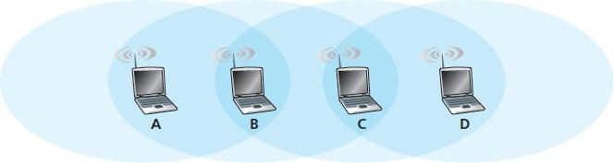

Suppose now that each node has an infinite supply of messages that it wants to send to each of the other nodes. If a message’s destination is not an immediate neighbor, then the message must be relayed. For example, if A wants to send to D, a message from A must first be sent to B, which then sends the message to C, which then sends the message to D. Time is slotted, with a message transmission time taking exactly one time slot, e.g., as in slotted Aloha.
During a slot, a node can do one of the following: (i ) send a message; (ii ) receive a message (if exactly one message is being sent to it), (iii ) remain silent. As always, if a node hears two or more simultaneous transmissions, a collision occurs and none of the transmitted messages are received successfully. You can assume here that there are no bit-level errors, and thus if exactly one message is sent, it will be received correctly by those within the transmission radius of the sender.
- Suppose now that an omniscient controller (i.e., a controller that knows the state of every node in the network) can command each node to do whatever it (the omniscient controller) wishes, i.e., to send a message, to receive a message, or to remain silent. Given this omniscient controller, what is the maximum rate (messages per slot arriving at A) at which a data message can be transferred from C to A, given that there are no other messages between any other source/destination pairs?
- Suppose now that A sends messages to B, and C sends messages to D. What is the combined maximum rate at which data messages can flow from A to B and from C to D?
- Suppose now that the wireless links are replaced by wired links. Repeat questions (a) and (b) again in this wired scenario.
Solution:
a)
1 message can be sent at maximum rate since when C sends a message A would do nothing and B would receive, then B would send a message, A would receive, and C would do nothing since it can’t send a message while B is busy.

b)
1 messages can be sent at maximum rate since while C is sending to D and B will also receive the same message since it is in the range. So if A were to send at the same time we would get a collision. Instead they need to take turns sending data.

c)
For a, 2 messages can be sent at the maximum rate. We can now receive and send on the same turn, so C will send to B, B will receive from C, B will send to A, and A will receive all at the same time.

For b, 2 messages can be sent at the maximum rate. We can now have B only receive from A and not receive from C accidently, so C and A can send simultaneously.

